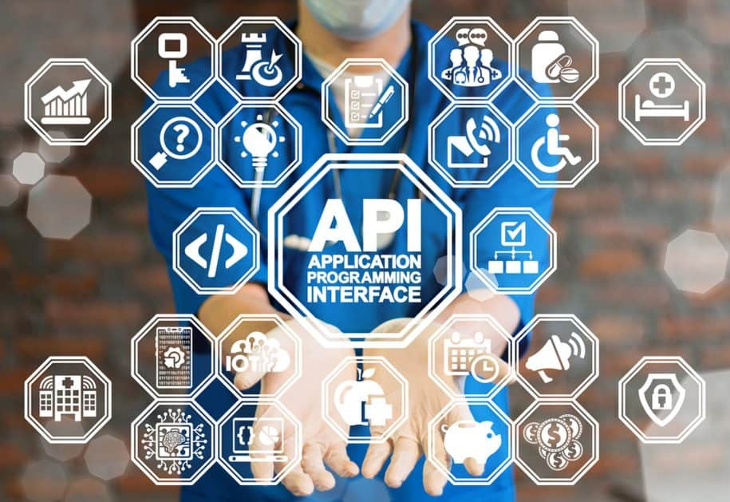



The National Center for Biotechnology Information (NCBI) is a branch of the National Institutes of Health (NIH) in the United States. It is an important resource for researchers, healthcare professionals, and individuals seeking information about biomedical research and genetics. NCBI provides free access to a vast amount of biomedical data, including scientific articles, genetic sequences, and medical information. Their website also offers tools and resources to help users analyze and interpret this data. Some examples of these resources include PubMed, GenBank, and BLAST.

PubMed is a search engine that allows users to find scientific articles on a wide range of biomedical topics. GenBank is a database of genetic sequences, while BLAST is a tool for comparing DNA or protein sequences to those in the database.

In addition to providing data and resources, NCBI also supports research and development in the field of biotechnology. They collaborate with other organizations and institutions to advance the understanding of genetics and molecular biology. An API is offered by the NCBI, which permits access to their comprehensive database of biomedical information programmatically.

<https://www.ncbi.nlm.nih.gov/>

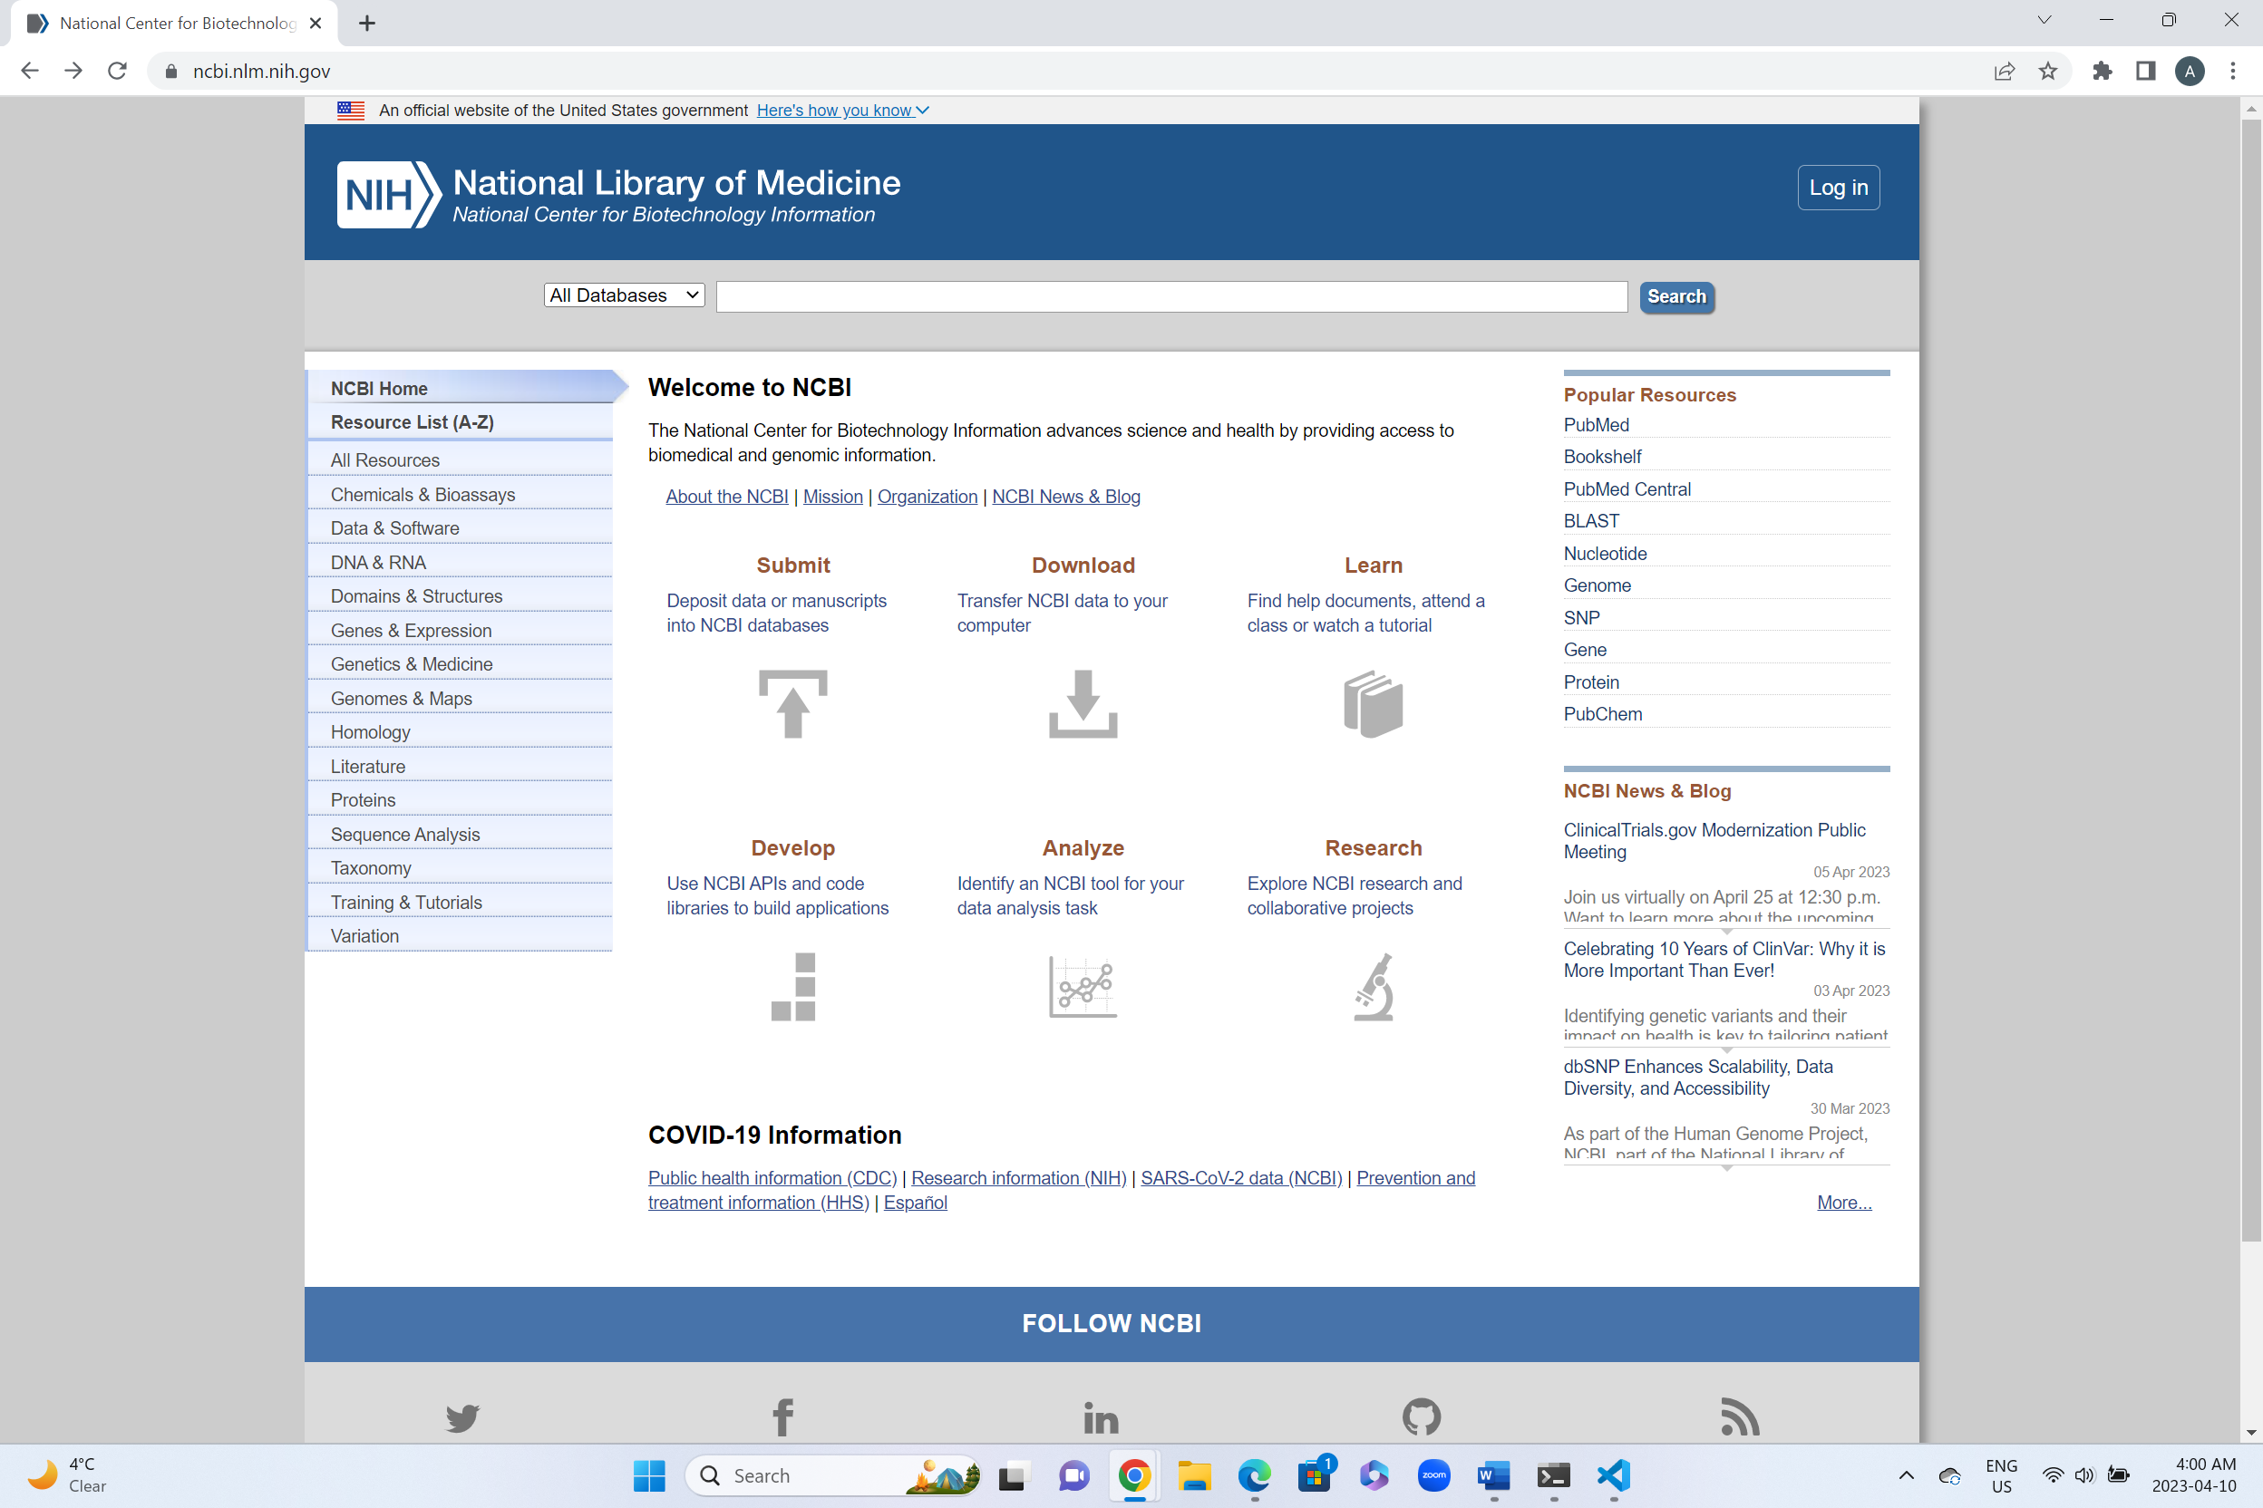

To acquire an API key, an NCBI account must be created, and an API key can be requested through the NCBI API Key Management page. The link for registration is as below:

[Log in / NCBI (nih.gov)](https://account.ncbi.nlm.nih.gov/)

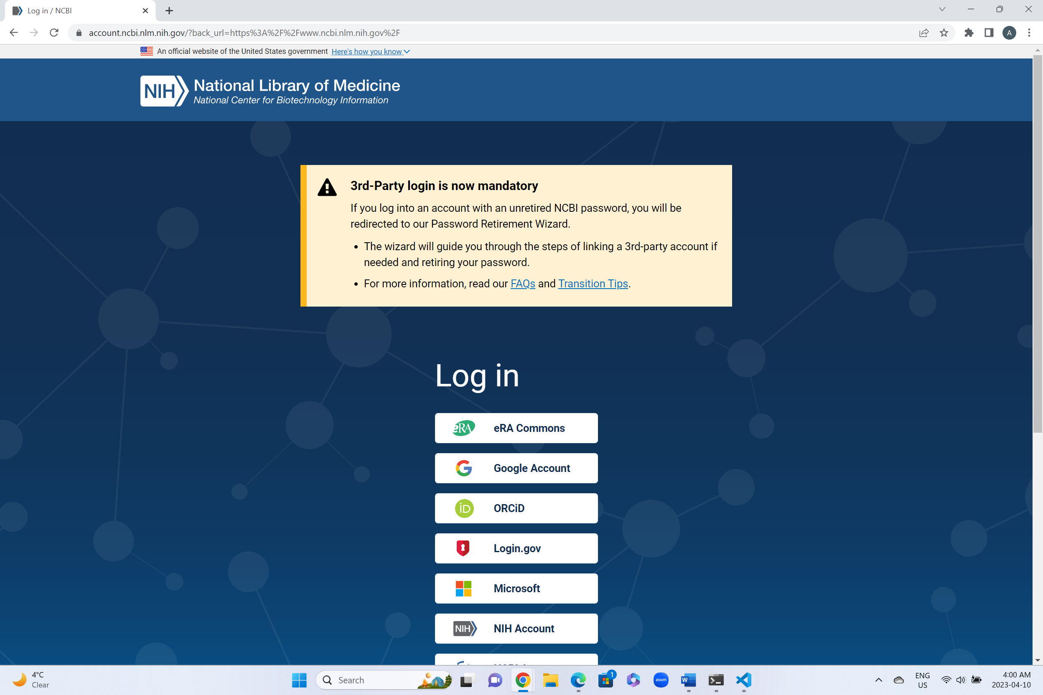

Using the account setting from the profile part, we can access to the API key management and generate a new API key.

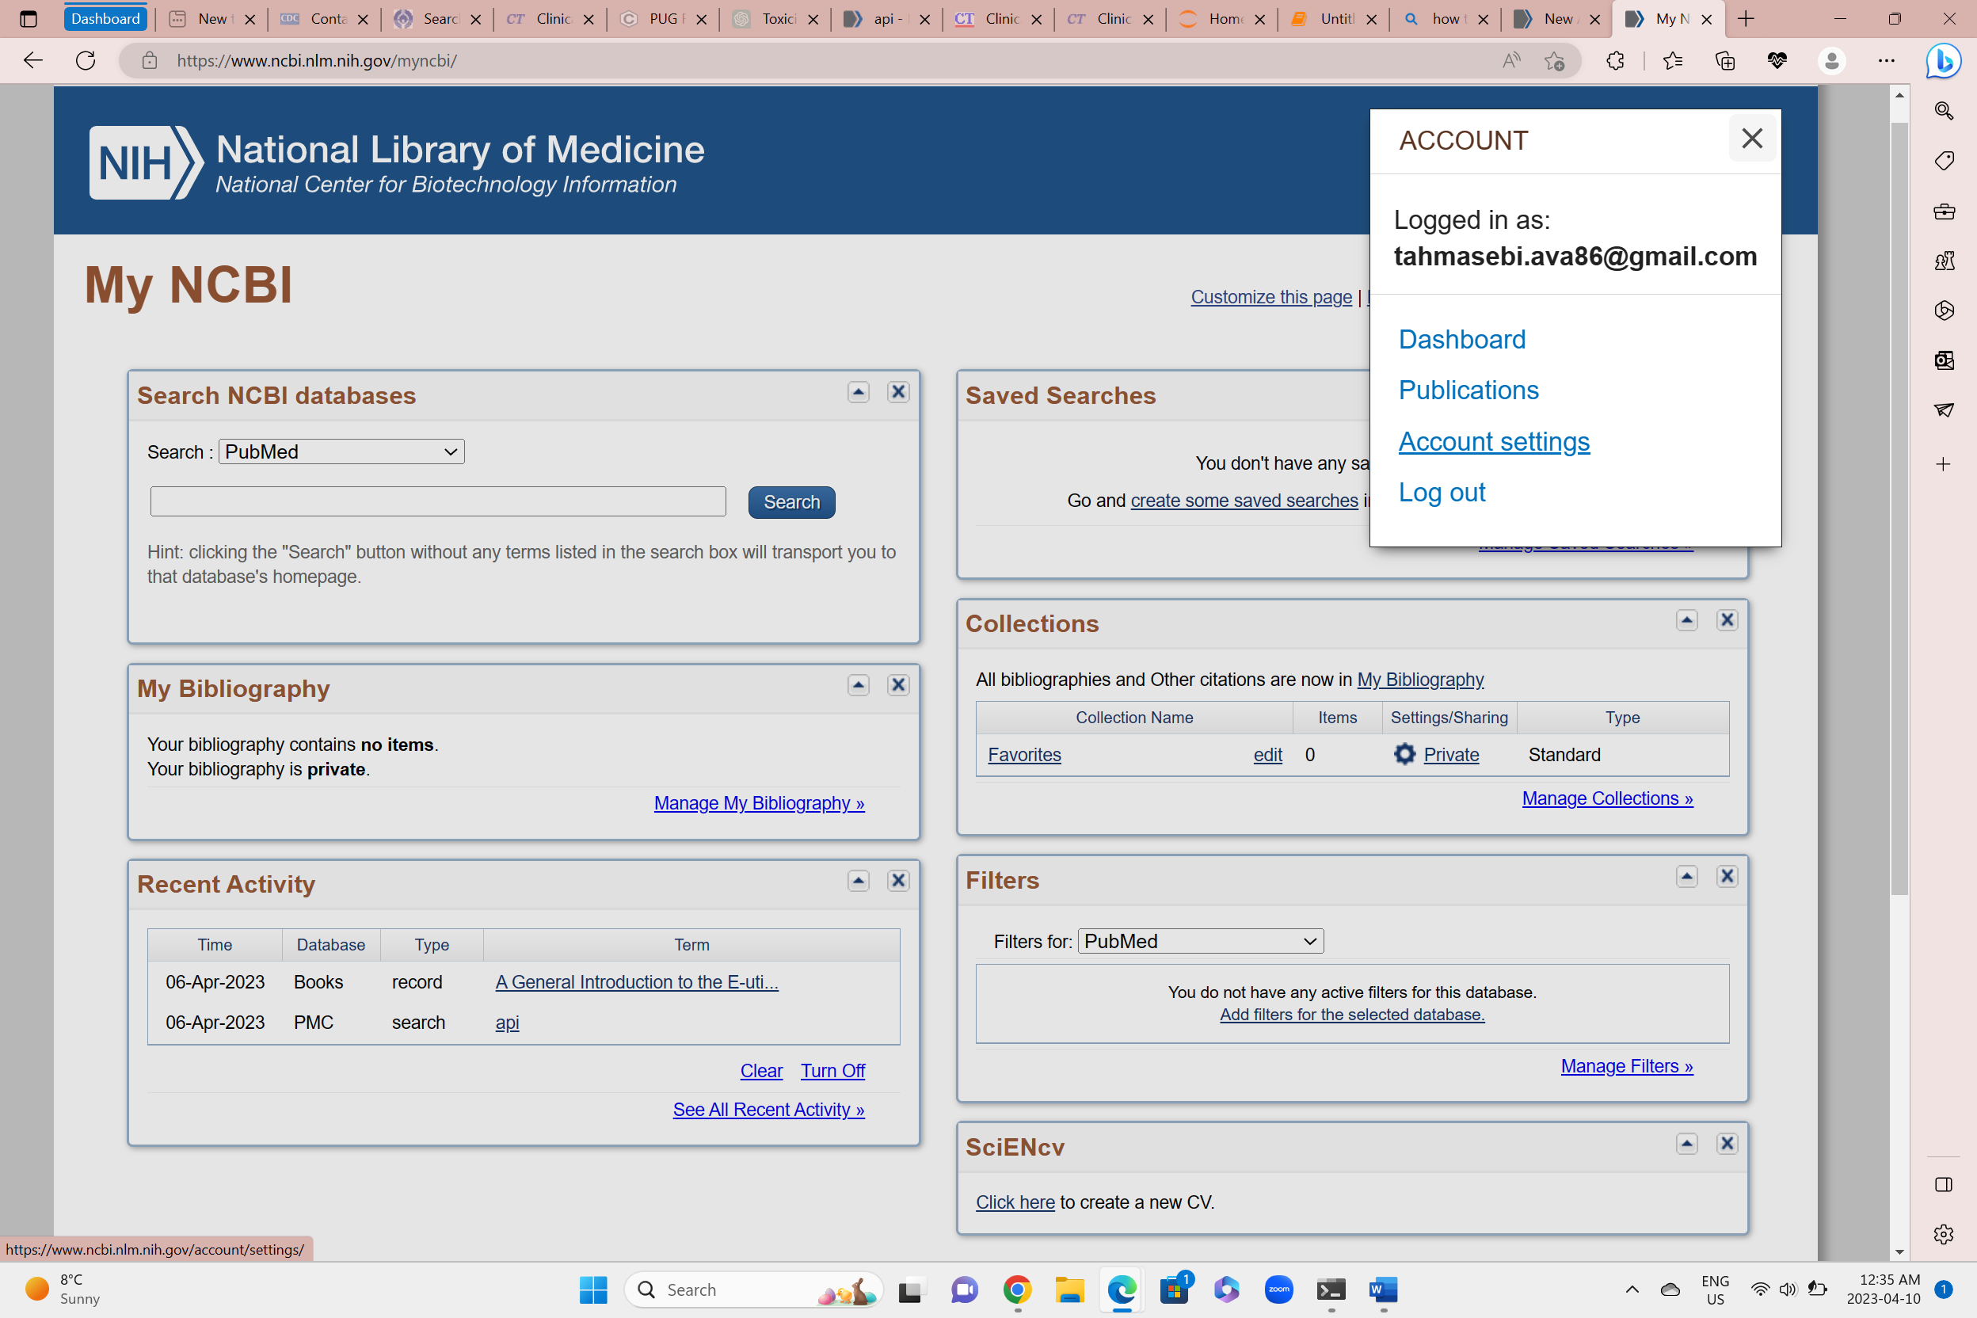

It is important to adhere to the guidelines and terms of use established by the NCBI when utilizing the API to ensure ethical and responsible use of the data. Assistance can be obtained from the NCBI support team if there are any issues or queries about the API.

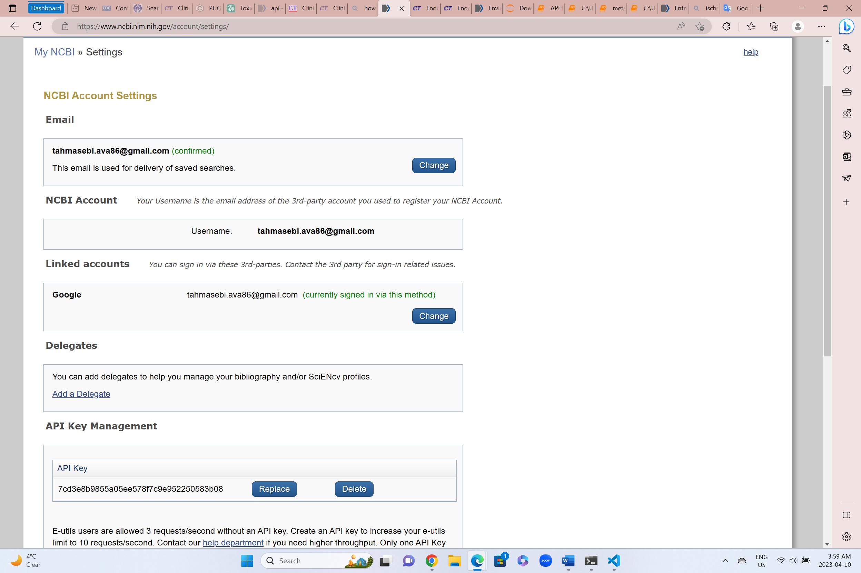

With this key, requests can be authenticated to the NCBI API, and scientific articles, genetic sequences, and medical data can be retrieved. This information can be useful for gaining insights into various health conditions, medical professionals, and researchers.

